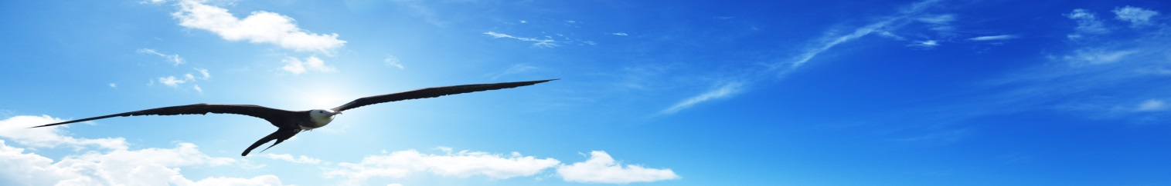
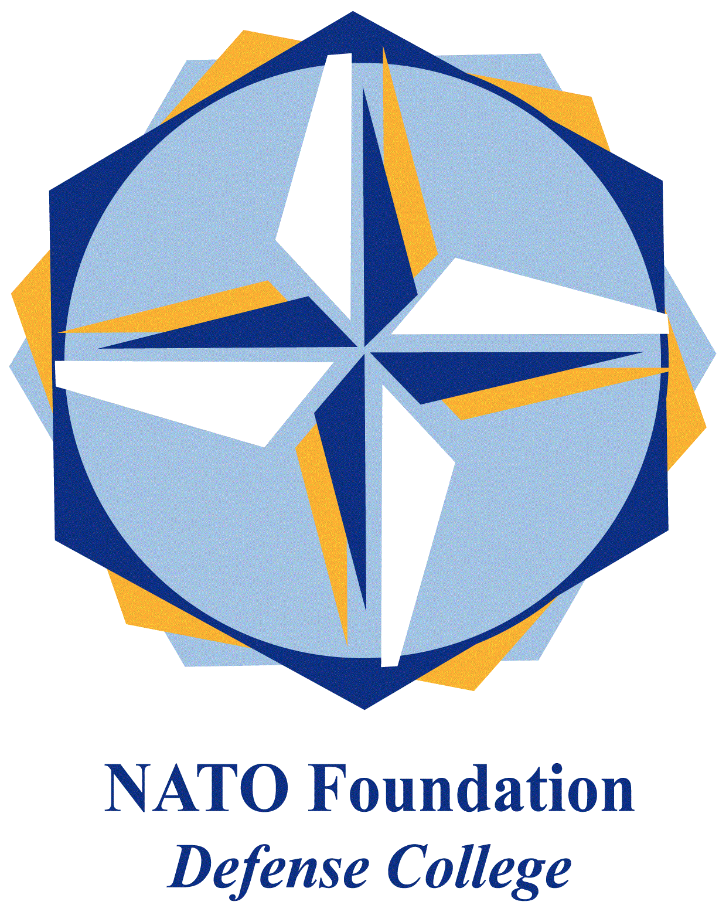
NATO DEFENSE COLLEGE FOUNDATION
STRATEGIC TRENDS
January 2016
MAGHREB
Morocco’s economic deals at risk over Western Sahara
In the last years Morocco has been praised as an example of political stability in a changing regional landscape. Despite several protests in January highlighted renewed social tensions inside the country, an unresolved issue is creating major problems to Rabat, worsening its relations with traditional allies: Western Sahara.
The territory was relinquished by Spain, the former colonial power, in 1975. Morocco and Mauritania occupied the area. Both countries engaged themselves in a fight against the Saharawi liberation movement, known as Polisario Front. The war, ignited by Algerian support for the Saharawi, lasted until 1991, when a UN-brokered ceasefire was signed in Houston, Texas. The deal provided for a national referendum to be held in the future, in which the Saharawi will have the opportunity to vote for complete independence or integration with Morocco.
In the last months relevant political developments regarding what is often called ‘Africa’s last colony’ have occurred. On 11th January the State Department of the United States (US) vetoed a Congress’ measure to provide economic assistance to Western Sahara. Foggy Bottom stated that the 2016 Federal Budget provision concerning Morocco cannot provide financial aid to a territory whose status has not been determined yet, contradicting the formal US policy over the issue.
The US position follows similar developments in Europe, where the 10th December 2015 the European Court of Justice suspended a trade deal between the European Union (EU) and Morocco. The EU’s top court stated that the deal failed to explicitly refer to Western Sahara and thus it can illegally apply to the disputed territory. The EU and US stances on Western Sahara represents an interesting trend in dealing with disputed territories, after the precedent of the trade deal row with Israel regarding products coming from settlements in the occupied territories.
Morocco was particularly angered at EU decision. Foreign Minister Salaheddine Mezouar warned about the future of EU-Morocco ties, stating that the rule set a dangerous precedent. Furthermore, the ruling did not produce any relevant result regarding the Western Sahara issue. Rather on 6th November, on the occasion of the 40th anniversary of the Green March, King Mohammed VI outlined a new development plan for the region, considering it as an integral part of the national territory. The king, who said he would offer no more than autonomy to the Saharawi, also announced a visit in the next weeks.
Despite EU and US are important commercial partners for Morocco, Rabat reaction shows how risky it is for Western governments to raise the stakes on the Saharawi issue. In September Moroccan authorities blocked the opening of the first Ikea store in the country. The official statement spoke about missing authorisations, but several sources indicated Sweden’s desire to recognize the Saharawi republic as the real reason behind the decision. As a result, in January 2016 Sweden was forced to announce that it will not to recognize Western Sahara.
Despite the international campaign in favour of the Saharawi and the sporadic interest of the public opinion, it is likely that Western governments will not jeopardize their partnership with Morocco and postpone any significant initiative addressing Polisario’s demands. Apart from economic reasons, the role of the kingdom in countering-terrorism is relevant, in particular regarding its collaboration with Western governments: according to media sources, Moroccan intelligence provided crucial information to French authorities during the November terrorist attacks in Paris, locating the mastermind behind the attacks.

